Chapter 1
$ git init # Initialize a new git database
$ git clone # Copy an existing database
$ git status # Check the status of the local project
$ git diff # Review the changes done to the project
$ git add # Tell Git to track a changed file
$ git commit # Save the current state of the project to database
$ git push # Copy the local database to a remote server
$ git pull # Copy a remote database to a local machine
$ git log # Check the history of the project
$ git branch # List, create or delete branches
$ git merge # Merge the history of two branches together
$ git stash # Keep the current changes stashed away to be used later

Chapter2
$ git –version
$ git config --global user.name "Mariot Tsitoara"
$ git config --global user.email "mariot.tsitoara@gmail.com"
Chapter 3
So for each project you want to start, you should

Create the directory containing your project
Navigate into the directory
Initialize a Git repository

$ mkdir mynewproject
$ cd mynewproject/
$ git init

As you can see in Figure 3-6 too, you can unstage a file using the Git command “git rm” with the option “--cached.” 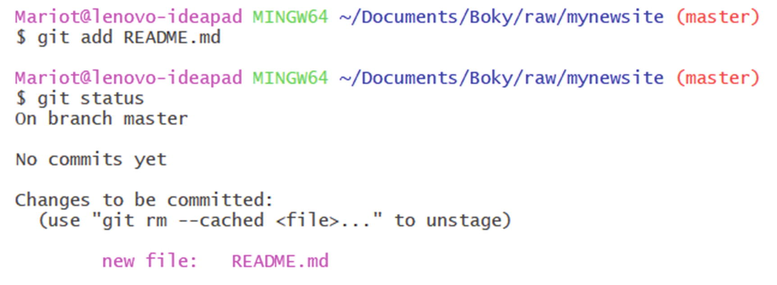
$ git rm --cached README.md

CautionDon’t forget the option “--cached” when unstaging a file. If you forget it, you could lose your file!

Note If a commit has two parents, that means that it was created by merging two branches.

The summary of the commit will contain a lot of information:
The current branch: master

The name of the previous commit: root-commit because this is our first commit

The name of the commit: the first seven letters of the commit hash

The commit message

The number of files changed: one file

The operation done to each file: creation
Chapter 4
If your commit history is very long, you can use the keyboard and go
- Forward or backward one line: key up and down OR j and k
- Forward or backward one window: f and b
- At the end of the log: G
- At the beginning of the log: g
- Get help: h
- Quit the log: q

Table 4-1
.gitignore lines and what they do
.gitignore line | What is ignored | Example
config.txt | config.txt in any directory | config.txt  local/config.txt
build/ | Any build directory and all files in it. But not a file named build | build/target.bin  build/output.exe  NOT output/build
build | Any build directory, all files in it, and any file named build | build/target.bin  output/build
∗.exe | All files with the extension .exe | target.exe  output/res.exe
bin/∗.exe | All files with the extension .exe in the bin/ directory | bin/output.exe
temp∗ | All files with name beginning by temp | Temp  temp.bin  temp_output.exe
∗∗/configs | Any directory named configs | configs/prod.py  local/configs/preprod.py
∗∗/configs/local.py | Any file named local.py in any directory named configs | configs/local.py  server/configs/local.py  NOT configs/fr/local.py
output/∗∗/result.exe | Any file named result.exe in any directory inside output | output/result.exe  output/latest/result.exe  output/1991/12/16/result
Chapter 5
To check a snapshot of the project, we use the “git checkout” command and pass the commit name as a parameter.

$ git checkout <name>
$ git checkout master

$ git revert <commit name>
You can revert any commit; just make sure to work on a clean working directory. So, don’t forget to stage and commit your files before reverting a commit.

Let’s revert the third commit! We just use git revert followed by the commit name.
$ git revert 5f57824

$ git commit –amend
Amending a commit takes everything in the staged area and makes a new commit with it. So, if you want to add a new file to the commit or remove a file from it, you can stage and unstage them at will. Reminder: to unstage a file, you have to use git reset HEAD <file>.

First, you should remove the last commit from your project with git reset. We will use the “--soft” option so that the edits we made stay on the working directory. HEAD~1 means the previous commit as HEAD is a reference to the current one.
$ git reset --soft HEAD~1
After this, you can unstage the file with git reset again:
$ git reset HEAD filenottocommit.txt
Check if the commands worked as intended by reviewing the current status of the project.
$ git status
CautionBe careful when you use the reset command. It’s very dangerous. Make sure to double check what you write.
Then stage the correct one.
$ git add fileforgotten.txt
Now that you staged the correct files, you can commit the project.
$ git commit

$ git commit –amend
You can change the commit message at will and then save and close the editor like always.

Chapter 6

Commit Messages:
You should not write messages longer than 50 characters.

Begin the message by a capital letter.

Don’t end the message with a period.

Use the present time and ditch unnecessary articles.

Commit messages should be consistent.

